Question 1

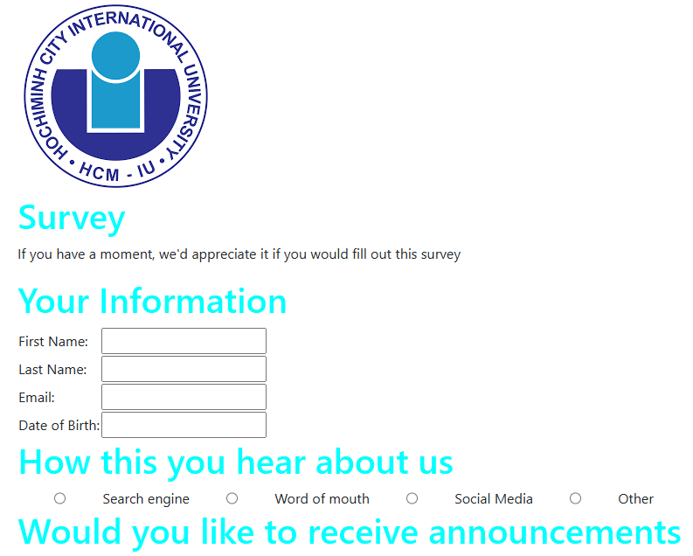

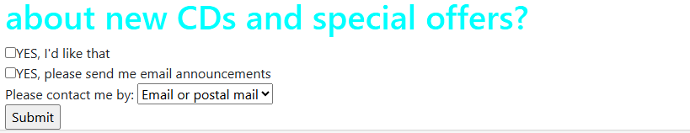

Question1.html

<!DOCTYPE html>

<html lang="en">

<head>

    <meta charset="UTF-8">

    <meta name="viewport" content="width=device-width, initial-scale=1.0">

    <title>Survey</title>

    <link rel="stylesheet" href="https://cdn.jsdelivr.net/npm/bootstrap@4.6.2/dist/css/bootstrap.min.css">

    <script src="https://cdn.jsdelivr.net/npm/jquery@3.7.1/dist/jquery.slim.min.js"></script>

    <script src="https://cdn.jsdelivr.net/npm/popper.js@1.16.1/dist/umd/popper.min.js"></script>

    <script src="https://cdn.jsdelivr.net/npm/bootstrap@4.6.2/dist/js/bootstrap.bundle.min.js"></script>

    <style>

        body{

            display: flex;

            margin-left: 200px;

            width: 800px;

        }

        .hear{

            display: flex;

            justify-content:space-evenly;

        }

        h1{

            color: cyan;

        }

    </style>

</head>

<body>

    <div class="container">

        <img src="images/iu favicon.png">

        <h1>Survey</h1>

        <p>If you have a moment, we'd appreciate it if you would fill out this survey</p>

        <form action="question1submit.jsp" method="post">

            <h1>Your Information</h1>

            <table>

                <tr>

                    <td>First Name:</td>

                    <td><input type="text" name="first_name" required></td>

                </tr>

                <tr>

                    <td>Last Name:</td>

                    <td><input type="text" name="last_name" required></td>

                </tr>

                <tr>

                    <td>Email:</td>

                    <td><input type="text" name="email" required></td>

                </tr>

                <tr>

                    <td>Date of Birth:</td>

                    <td><input type="text" name="dob" required></td>

                </tr>

            </table>

            <h1>How this you hear about us</h1>

            <div class="hear">

                <input type="radio" name="search engine" value="se">Search engine

                <input type="radio" name="mouth" value="wom">Word of mouth

                <input type="radio" name="social media" value="sm">Social Media

                <input type="radio" name="other" value="o">Other

            </div>

            <h1>Would you like to receive announcements about new CDs and special offers?</h1>

            <input type="checkbox" name="yes like" value="yl">YES, I'd like that<br>

            <input type="checkbox" name="yes announcements" value="ya">YES, please send me email announcements<br>

            Please contact me by: <select name="Type">

                <option value= EoP>Email or postal mail</option>

                <option value= Eo>Email only</option>

                <option value= Po>Postal mail only</option>

               </select><br>

            <input type="submit" value="Submit">

        </form>

</body>

</html>

Question1submit.jps

<!DOCTYPE html>

<html lang="en">

<head>

    <meta charset="UTF-8">

    <meta name="viewport" content="width=device-width, initial-scale=1.0">

    <title>Submit</title>

    <link rel="stylesheet" href="https://cdn.jsdelivr.net/npm/bootstrap@4.6.2/dist/css/bootstrap.min.css">

    <script src="https://cdn.jsdelivr.net/npm/jquery@3.7.1/dist/jquery.slim.min.js"></script>

    <script src="https://cdn.jsdelivr.net/npm/popper.js@1.16.1/dist/umd/popper.min.js"></script>

    <script src="https://cdn.jsdelivr.net/npm/bootstrap@4.6.2/dist/js/bootstrap.bundle.min.js"></script>

</head>

<body>

    <h1>Thank You!</h1>

    <p>Wait for approving by advisor</p>

</body>

</html>

Question 2

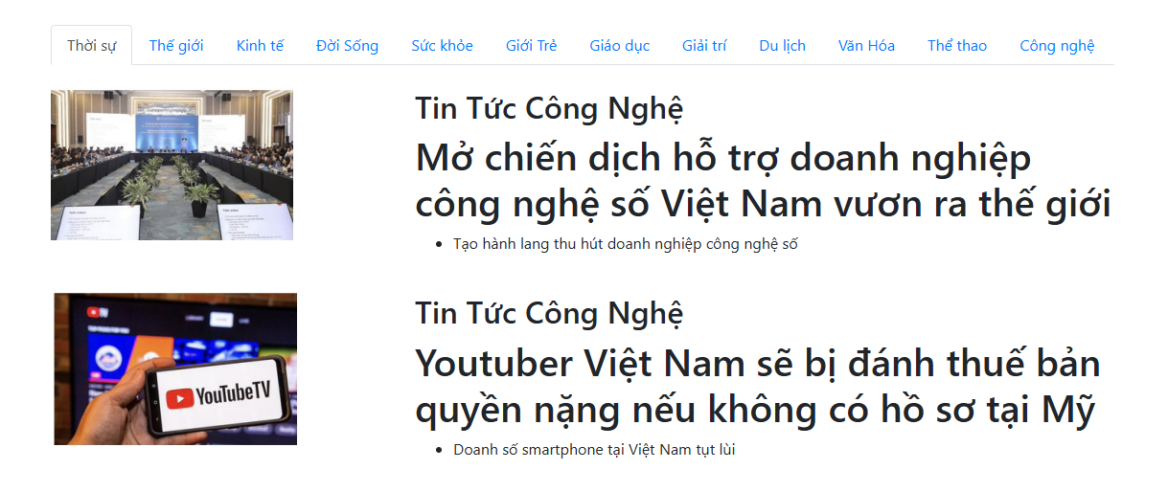

Question2.html

<!DOCTYPE html>

<html lang="en">

<head>

    <meta charset="UTF-8">

    <meta name="viewport" content="width=device-width, initial-scale=1.0">

    <title>Thời sự</title>

    <link href="https://stackpath.bootstrapcdn.com/bootstrap/4.5.2/css/bootstrap.min.css" rel="stylesheet">

    <script src="https://code.jquery.com/jquery-3.5.1.slim.min.js"></script>

    <script src="https://cdn.jsdelivr.net/npm/@popperjs/core@2.0.7/dist/umd/popper.min.js"></script>

    <script src="https://stackpath.bootstrapcdn.com/bootstrap/4.5.2/js/bootstrap.min.js"></script>

</head>

<body>

    <div class="container mt-5">

        <ul class="nav nav-tabs">

            <li class="nav-item">

                <a class="nav-link active" href="#thoi-su">Thời sự</a>

            </li>

            <li class="nav-item">

                <a class="nav-link" href="#the-gioi">Thế giới</a>

            </li>

            <li class="nav-item">

                <a class="nav-link" href="#kinh-te">Kinh tế</a>

            </li>

            <li class="nav-item">

                <a class="nav-link" href="#doi-song">Đời Sống</a>

            </li>

            <li class="nav-item">

                <a class="nav-link" href="#suc-khoe">Sức khỏe</a>

            </li>

            <li class="nav-item">

                <a class="nav-link" href="#gioi-tre">Giới Trẻ</a>

            </li>

            <li class="nav-item">

                <a class="nav-link" href="#giao-duc">Giáo dục</a>

            </li>

            <li class="nav-item">

                <a class="nav-link" href="#giai-tri">Giải trí</a>

            </li>

            <li class="nav-item">

                <a class="nav-link" href="#du-lich">Du lịch</a>

            </li>

            <li class="nav-item">

                <a class="nav-link" href="#van-hoa">Văn Hóa</a>

            </li>

            <li class="nav-item">

                <a class="nav-link" href="#the-thao">Thể thao</a>

            </li>

            <li class="nav-item">

                <a class="nav-link" href="#cong-nghe">Công nghệ</a>

            </li>

        </ul>

        <div class="mt-4 row">

            <div class="col-md-4">

                <img src="images/quochoi.jpg" alt="" class="img-fluid">

            </div>

            <div class="col-md-8">

                <h2 id="thoi-su">Tin Tức Công Nghệ</h2>

                <h1>Mở chiến dịch hỗ trợ doanh nghiệp công nghệ số Việt Nam vươn ra thế giới</h1>

                <ul>

                    <li>Tạo hành lang thu hút doanh nghiệp công nghệ số</li>

                </ul>

            </div>

        </div>

        <div class="mt-4 row">

            <div class="col-md-4">

                <img src="images/youtube.jpg" alt="" class="img-fluid">

            </div>

            <div class="col-md-8">

                <h2 id="thoi-su">Tin Tức Công Nghệ</h2>

                <h1>Youtuber Việt Nam sẽ bị đánh thuế bản quyền nặng nếu không có hồ sơ tại Mỹ</h1>

                <ul>

                    <li>Doanh số smartphone tại Việt Nam tụt lùi</li>

                </ul>

            </div>

        </div>

    </div>

</body>

</html>

Question 5

